Microearthquake Sequence Events in the Yarrol Block, Central Queensland

Version: 20250711

By Mike Turnbull [turnbulm49@gmail.com](mailto:turnbulm49@gmail.com)

On 26 June 2025 eight small earthquakes were recorded on Geoscience Australia’s Eidsvold seismic monitoring station (EIDS). Of those eight events three were sufficiently recorded on other Queensland stations to enable them to be located to the Yarrol Block, between Monto and Mt Perry. The following day another 20 earthquakes were recorded on EIDS; and, due to the statistically similar value of the S-P delta times of all 25 unlocated events, and some trigonometric analysis of the P arrivals, I was able to assume that all the 28 events occurred within close proximity of one another.

This prompted me to go back over my seismic records looking for similar sequence events in that same Yarrol Block area. I found that a sequence event occurred on 28 June 2024, within 21 minutes of one another, precisely a year earlier than those on 26 June 2025.

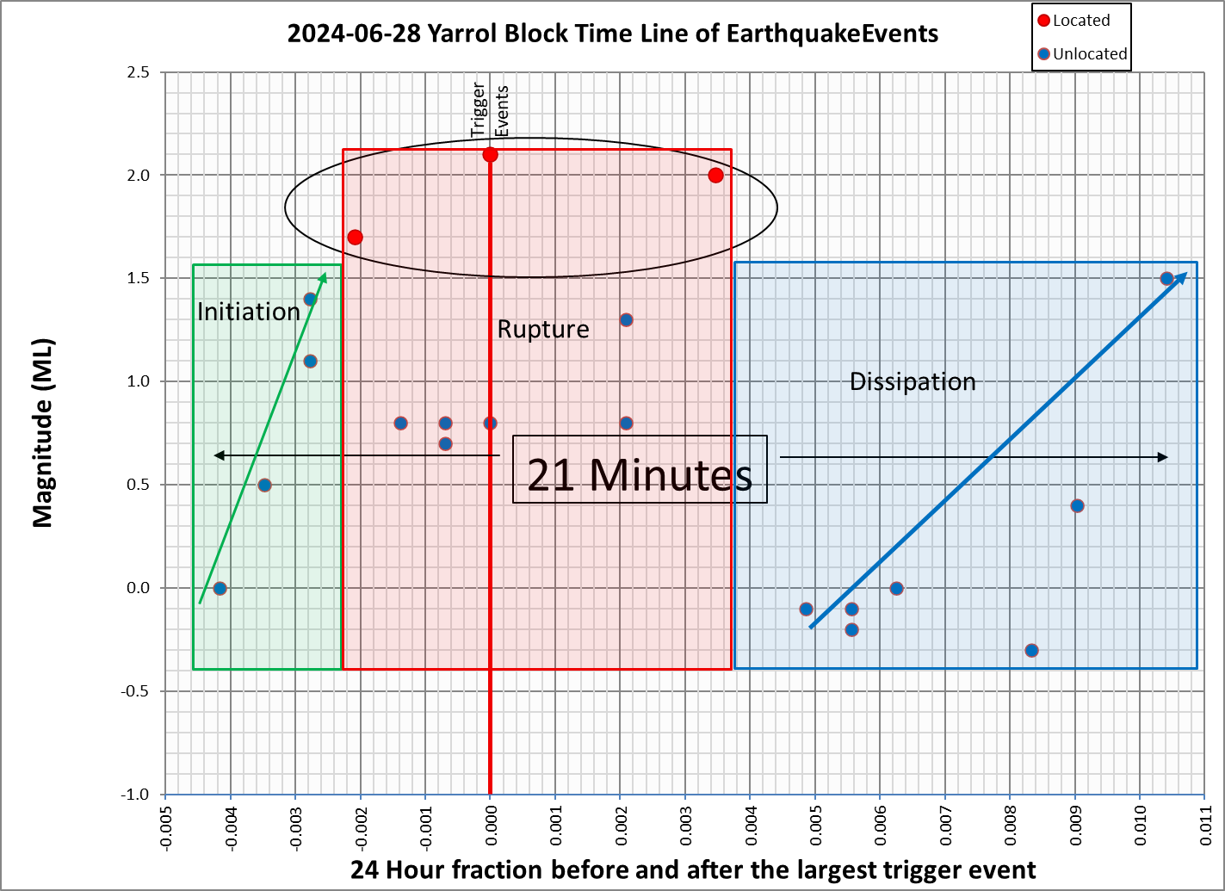

Figure : The July 2024 earthquake sequence event.

The 2024 sequence event displayed certain observable characteristics, as depicted in Figure 1. I have designated these characteristics as Initiation, Rupture, and Dissipation phases of the sequence.

The physics of the state phases may be broadly described as follows.

* During the Initiation phase a sequence of very small earthquakes transition the event volume from the quiescent state, through incipiency, to a pregnant state.
* During the Rupture phase the largest of the earthquakes in the sequence occur, and there may be associated smaller earthquakes.
* During the Dissipation phase small earthquakes occur, possibly initiated by the rebound energy and dissipation of the local stress that caused the overall sequence.

In comparison to the 2024 June 26/27 sequence event, the June 2025 sequence event (Event 1 in Figure 2) only exhibited the Rupture, and Dissipation phases – there was no discernable Initiation phase.

There are four possible combinations of state change as shown in Table 1 below.

Table : Possible Earthquake Sequence Event Types.

|  |  |  |  |
| --- | --- | --- | --- |
| Sequence Type | Initiation Phase | Rupture Phase | Dissipation Phase |
| Type 1 |  |  |  |
| Type 2 |  |  |  |
| Type 3 |  |  |  |
| Type 4 |  |  |  |

By manual scanning the EIDS records over the 13 days following 26 June 2025 I was able to detect three subsequent microearthquake sequence events, and these are shown in Figure 2.

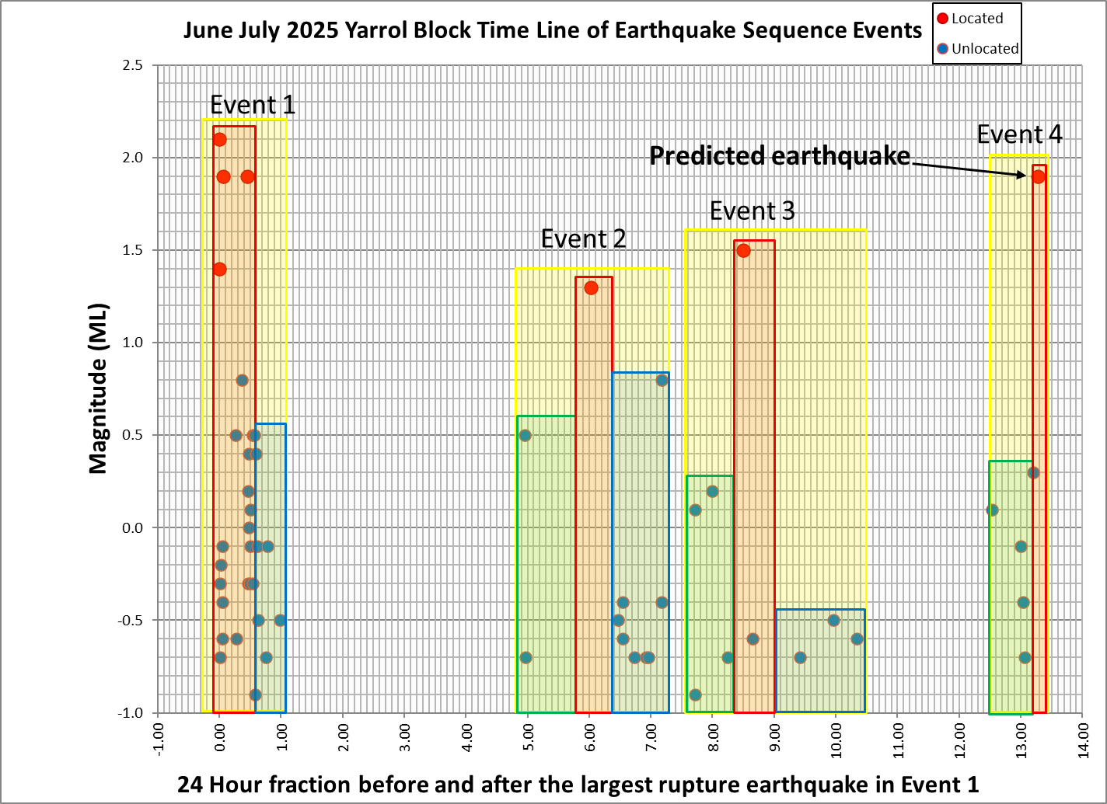

Figure : The four June/July 2025 earthquake sequence events.

Events 2 and 3 exhibited all three event phases (Type 1 in Table 1), and there were obvious hiatus gaps between Events 1, 2, and 3.

Following Event 3 there was a 2-day hiatus; and then, on 9 July, I detected five microearthquakes within 15 minutes of one another. It was then that I took the bold step of emailing Kevin McCue and advising him *“… that the Yarrol Block will have an ML 1.0 to 1.5 within the next 24 to 36 hours.*”

It turned out that it didn’t take that long. Within an hour of the most recent microearthquake in that sequence a magnitude ML1.9 earthquake occurred (seeFigure 2, Event 4); and I was able to get sufficient records from other stations to locate it to the Yarrol Block.

In reporting my observations on this matter, I make no attempt to explain how or why what is being observed is occurring. The simple fact is that they occur in a consistently observable manner, and that predictive meaning can be attached to the observations.

So, what can be made of this set of observations? I suggest the following.

* There is a situation in the Yarrol Block whereby small earthquake sequence events are repeatedly occurring with predictable characteristics.
* Based on three of those sequence events I have been able to predict the fourth rupture event within an hour of it occurring.
* The physics underpinning the event characteristics can be justified.
* I have no idea whether these four events indicate a large future event – only time will tell.
* The Yarrol Block is special in that it is an isolated fracture area that has historically generated at least four earthquakes of magnitudes greater than or equal to ML5 within the past 110 years.
* The last time this sort of earthquake sequence event occurred in the Yarrol Block (prior to this current set of four events) was in June 2024, just one year previous, and there was no significantly large earthquake following that event.
* I am not trying to compare my observations with those in WA by Vic Dent. Vic is his own person, and I will leave it to him to make his own observations, just as I do mine.
* If there are similar reports in Australia to what I am seeing, then perhaps more credence should be put on those reports.
* I am not trying to say that my current observations can be used to predict large and damaging earthquakes anywhere in Australia; but it seems certain that the prediction of small seemingly insignificant events within the future one to  24 hours in the Yarrol Block is a perfunctory exercise using the data from a seismic monitoring station within 50 km of the events and manual scanning of the waveforms.

A catalogue of the located events referred to above can be obtained off my web site at <https://cqsrg.org/catalogue/>.

Excel spreadsheets of the 2024 and 2025 events used to create Figure 1 and Figure 2 can be downloaded off my web site at <https://cqsrg.org/tools/download/> as can Microsoft Word and PDF versions of this document.